“REAL ESTATE AGENCY”

Submitted by:
- Moghees Mohiuddin Roll No. 2025-CS-210
- M. Arslan Emran Roll No. 2025-CS-200
- M. Shahzaib Roll No. 2025-CS-204
- MA. Choudhary Roll No. 2025-CS-184
- Muhammad Anas Roll No. 2025-CS-229

Course Instructor:
Miss Ramsha Khalid

Course:
CSC-100L Applications of Information and Communication Technologies H

Session: Fall 2025
Section: D (Morning)
Date: 22 December 2025



INTRODUCTION
A real estate agency is a professional company that assists customers with the purchase, sale, and management of real estate, including commercial buildings, villas, apartments, and land. It serves as a reliable conduit between buyers, agents, and property owners, guaranteeing that all real estate transactions are managed in an organised, safe, and open way.
The creation of a real estate website that offers consumers a structured online platform is the main goal of this project. The Home page helps visitors quickly grasp the website's goal by providing an overview of the services and properties that are highlighted. The Buy section makes it simpler and more effective for users to search for real estate by enabling them to examine various property categories, such as land, commercial properties, apartments, and villas. Property owners can list their properties on the Sell page and use the agency to connect with possible buyers.
The Agents page presents qualified real estate brokers who assist clients during the purchasing and selling process in order to improve communication and trust. The agency's mission, values, and real estate market experience are described on the "About Us" page. Additionally, users can share their experiences and recommendations on the Feedback page, which enhances customer satisfaction and service quality.
This project's primary goal is to provide a user-friendly website that illustrates the fundamental functions of a real estate company. It makes finding properties easier, encourages well-organised data management, and gives users clear information based on their needs and financial constraints. Overall, the website presents a structured and practical model of how modern real estate businesses operate using digital technology

OBJECTIVES AND SCOPE
This project's primary goal is to create a website for a real estate agency that offers concise, well-organised details about available properties. Viewing property listings and getting in touch with the agency should be simple for users thanks to the website.
The project's particular goals are:

- To create a home page that effectively presents the real estate company and its offerings.

- To create a Buy section for villas, apartments, commercial, and land.

- To offer thorough and arranged property details on the Buy pages.

- To develop a Sell page where property owners can quickly submit the details of their properties.

- To present a page with agent profiles and contact details for professional agents.

- To assist users in selecting appropriate agents according to their real estate requirements

- To add an About Us page outlining the company's history, goals, and core principles.

- To increase user trust by providing clear and truthful company information

- To create a feedback page where users can offer recommendations and experiences.

- To enhance customer service and website quality by utilising user feedback
DATA SUMMARY & OBSERVATION

Types of properties available for our valuable clients
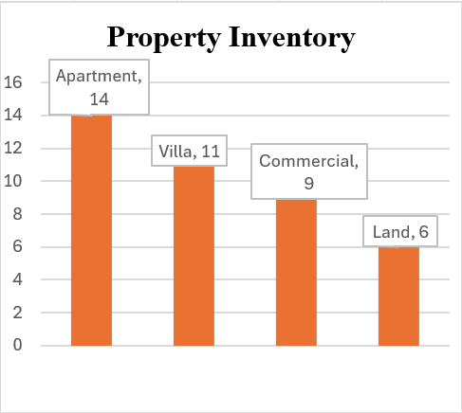

Status of Properties offered available, sold, rented etc.
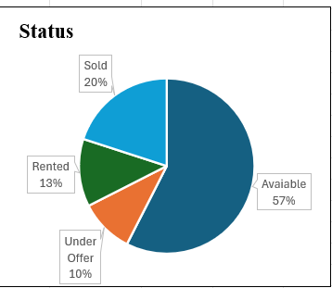
Status of deals carried out (active, closed or completed)
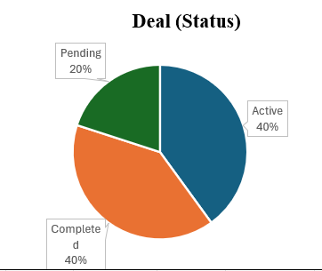

Types of clients (Buyers or Tenants)
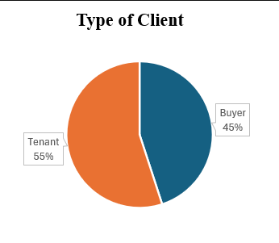

Here is some of the data about our business sales, profits etc.

Total Sales Value | $1,671,832.50 | $24,025,000.00
Total Rental Value | $103,150.50 | $57,650.00
Total Gross Commission | $80,334.38 | $659,805.00
Operational Expenses | $50,000.00 | $50,000.00
Net Profit | $30,334.38 | $609,805.00
Average Deal Value | $44,374.58 | $602,066.25

SITE STRUCTURE AND NAVIGATION
Our website is on Real Estate and the main focus of our site is to facilitate our clients and customers in buying, selling and take properties on rent. We try our best to provide basic features easily available in order to buy/sell properties.
Our site consist of 6 pages
- Home
- Buy
- Sell
- Agents
- About us
- Feedback.
- Mortgage
- Gallery
HOME:
First page of our website is home page; it is also as introductory page of our website.
It also tells the purpose of our website.

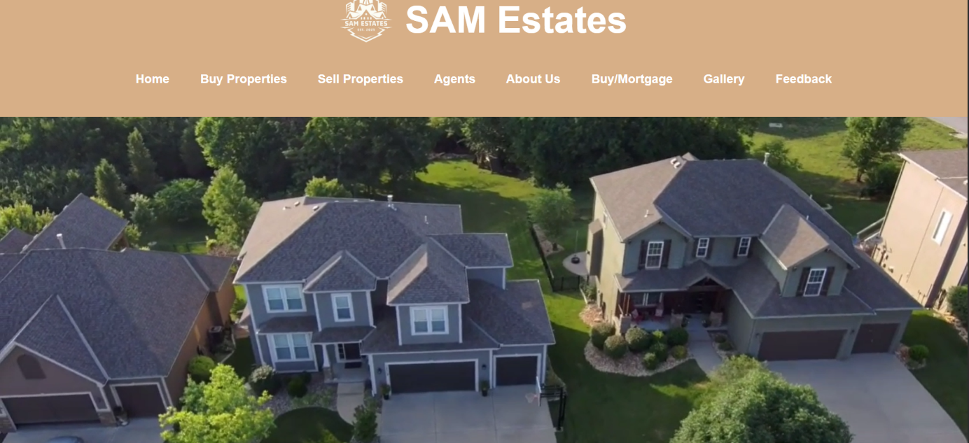

BUY AND SELL:
These pages are one of the main pages of our site. Here we listed the properties we offered such as Apartments, Villas, Commercial, Land.
In sell section we also provide our beloved customers to list their properties for sell also to facilitate them in this purpose also because it is also one of the main objects of Real Estate.
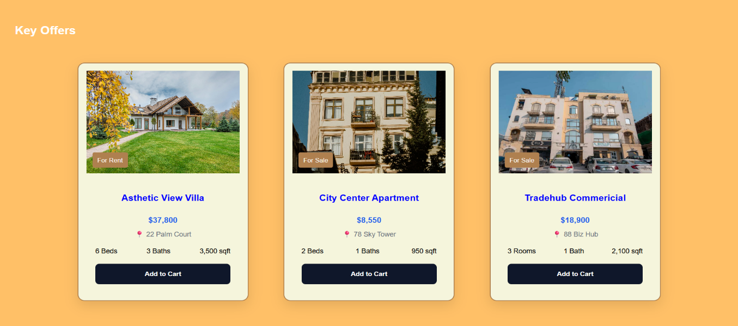
Agents:
This page is also very important because here we provide the facility to take some help regarding properties from professional agents that are working on ground in Real Estate. Here we list some of our professional agents. We are also assured by their work ethics and professionalism so that our customers satisfied fully.

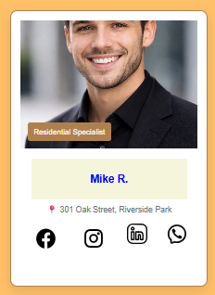

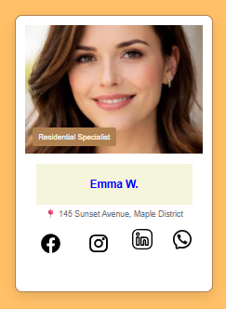


Mortgage:
This page of our website is for those persons that are unable to buy land and full prices, we provide them the opportunity to acquire the land fully and pay us in installments further.
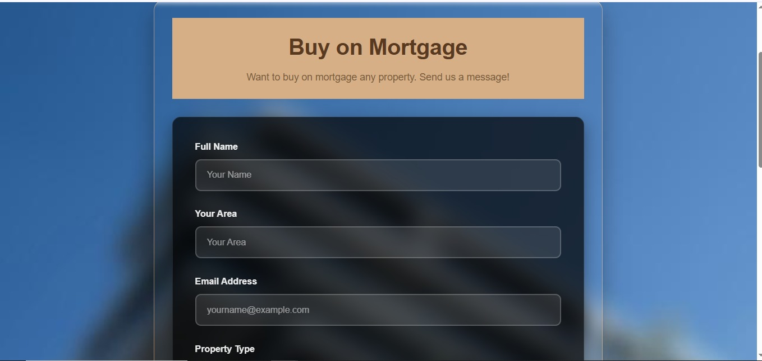

Gallery:
Here we include the pictures of available properties so that our clients can understand the conditions of the properties easily and can make their decisions easily.
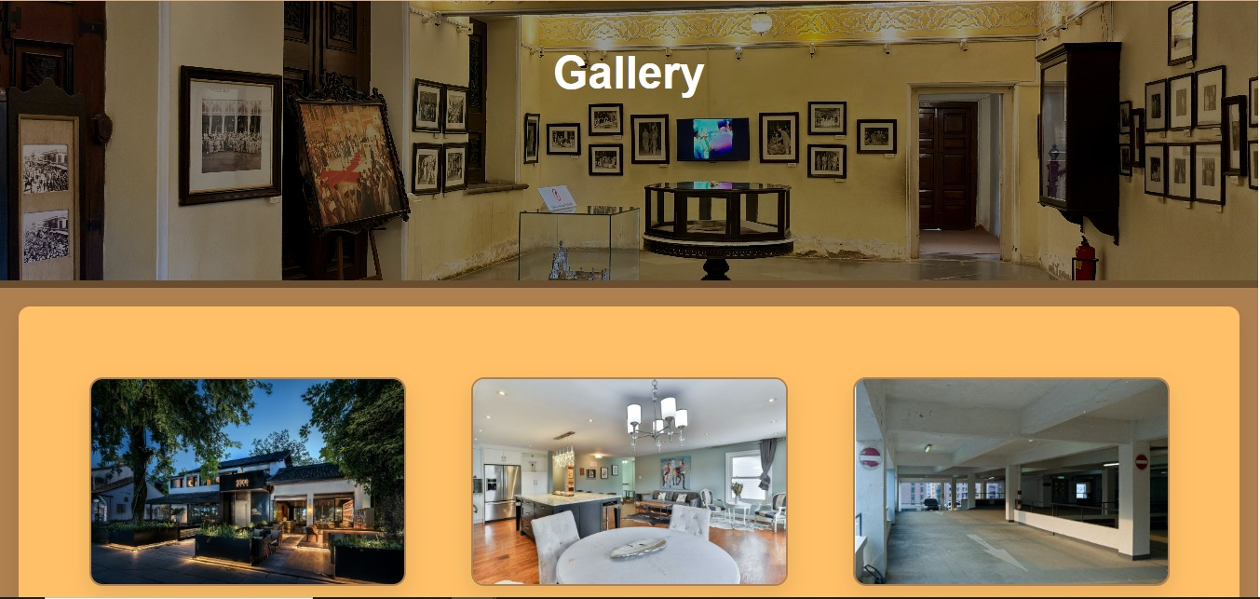

About us:
Here we provide the information of ourselves that who are responsible for the site and who are actually behind all the stuff controlling and managing the site to facilitate our customers.
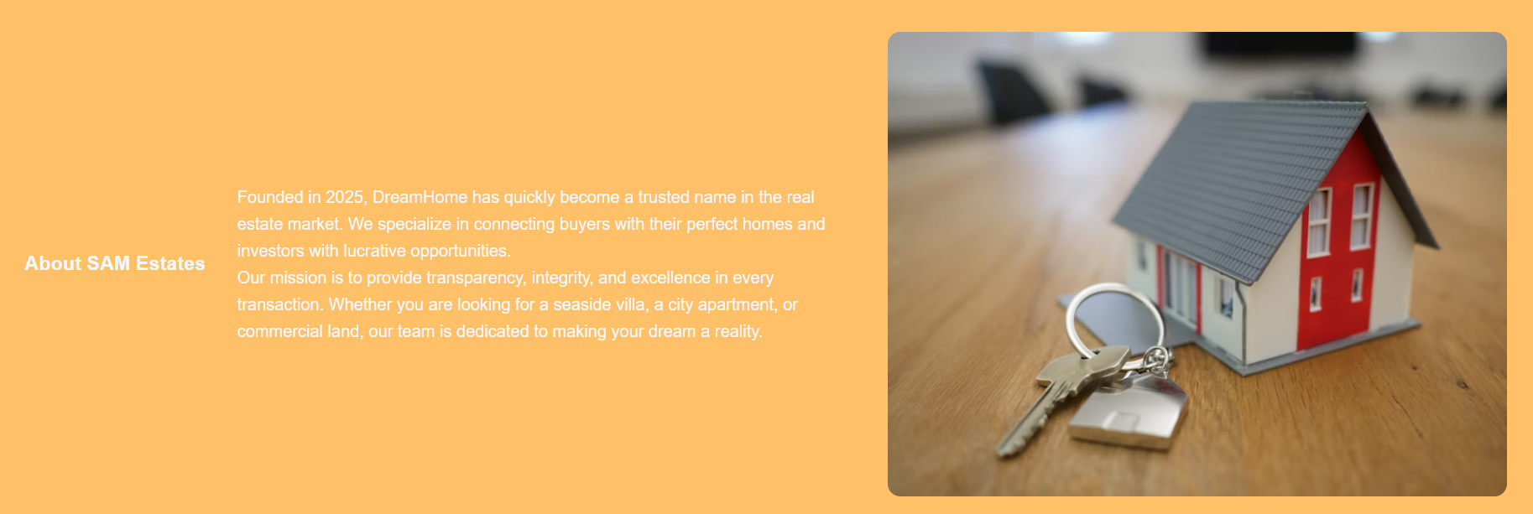

Feedback:
This page is specially for our beloved customers to provide feedback of our site and tells us our mistakes and issue regarding sites and also suggestions to improve all the stuff on the website

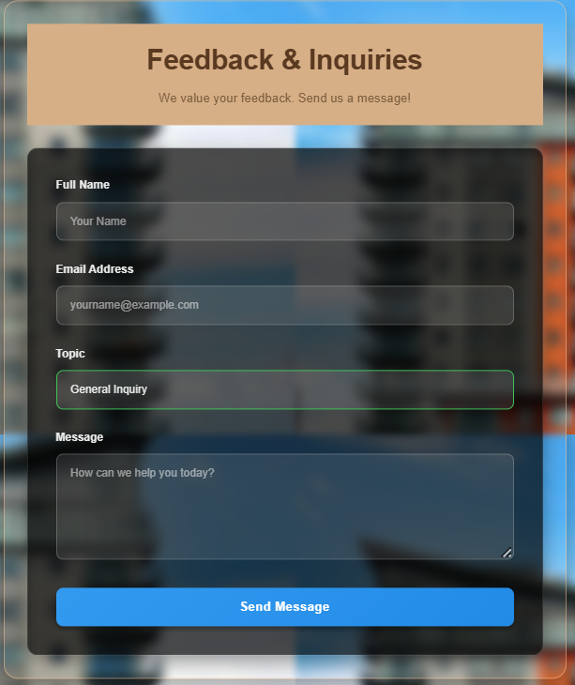
HOW TO RUN AND PUBLISH THE SITE

- Organize all files (HTML, CSS, images, etc.) in a single folder.
- Ensure file paths are relative (e.g., css/style.css) to avoid broken links.
Create a GitHub Repository
- Sign in to GitHub and create a new repository.
- Name it appropriately
Upload Project Files
- Click Add Files → Upload Files in your repository.
- Drag your project folder files and commit changes.
Enable GitHub Pages
- Go to Settings → Pages in your repository.
- Under Source, select the branch main and folder root through yml.
- Click Save.
Get Your Live URL
- GitHub will provide a URL like:
- https://your-username.github.io/repository-name/
- Open it in a browser to check your live site.
Update and Maintain
- Any changes you make locally can be uploaded to GitHub again.
- The live site updates automatically after committing changes

LIVE URL: https://bit.ly/45hm94z

GITHUB LINK: https://bit.ly/3Lbphbh

Reflections (What Was Learned)

- Real estate agencies help clients buy, sell, and rent properties, making the process easier and more organized.
- Keeping accurate records of available properties is important to provide correct information to clients.
- Understanding client needs, such as property type, location, and budget, is essential for offering suitable options.
- Displaying property details on a website, including price, location, and type, improves client accessibility.
- The role of agents and proper communication is key in guiding clients through property transactions.

Improvements (Areas for Enhancement)

- Add search filters on the website to make finding homes, apartments, villas, land, or commercial property faster.
- Include more detailed images or virtual tours for properties to give clients a better view without visiting.
- Implement a feedback system to gather client opinions and improve services.
- Ensure property listings are updated frequently to remove sold or rented properties.
- Introduce notifications for clients about new properties matching their preferences.

